ASSIGNMENT NO 2:

PREDICT BRAIN SIZE FROM HEAD SIZE :

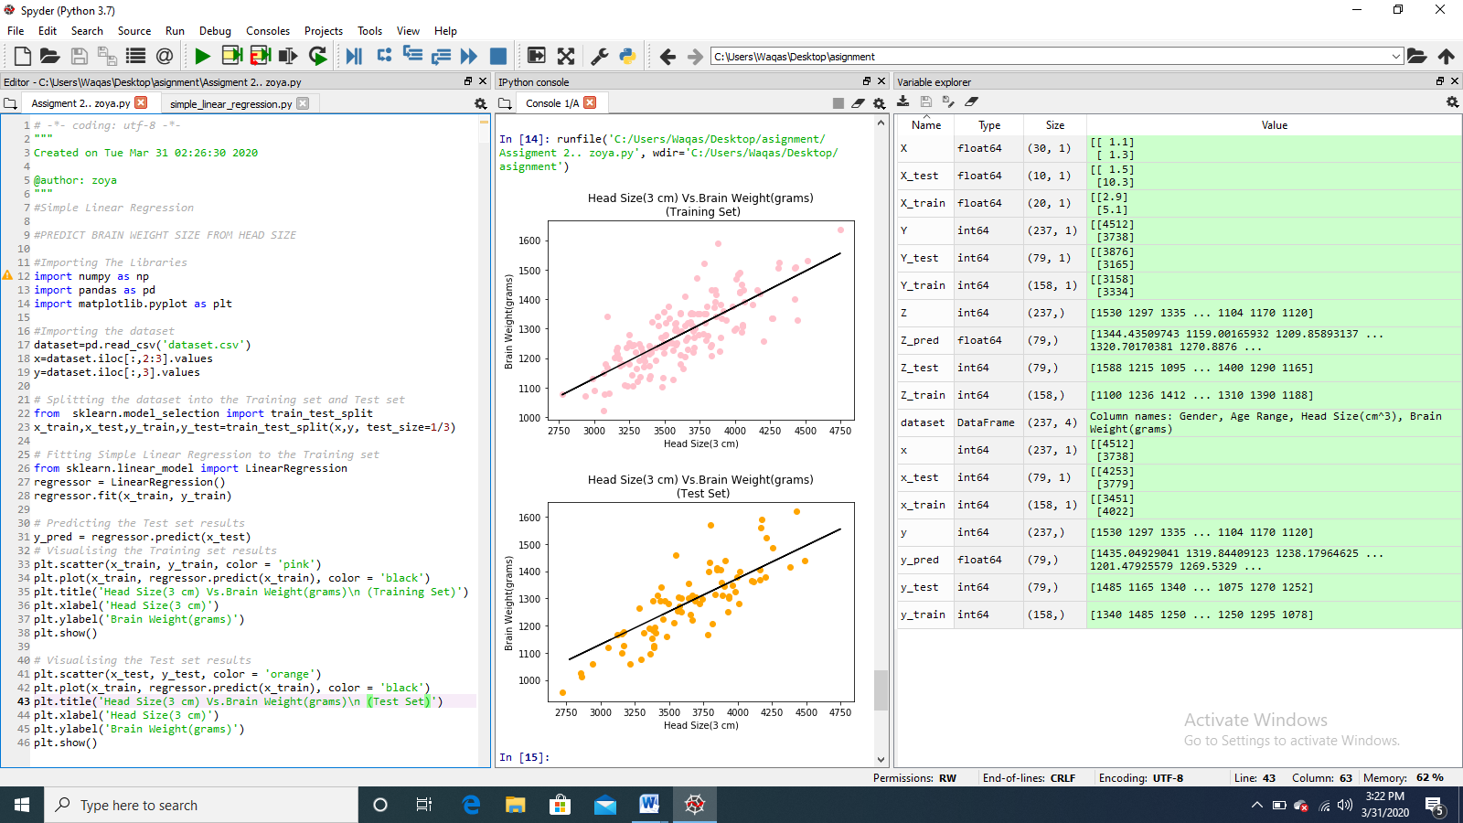

CODE: RUN:

 

VARIABLE EXPLORER:

